 | Course Name: Design Patterns/Thinking LAB | EXPERIMENT NO. 15
 | Course Code: 20CP210P  Faculty: Dr. Payal Chaudhari | Branch: CSE | Semester: IV
(To be filled by Student)
Submitted by: Meet Jain
Roll no: 23BCP093

Objective: To familiarize students with standard Behavioral design patterns.
Experiment: Explain the MVC design pattern and write a program using any object-oriented programming language to demonstrate the working of MVC design pattern.

Code:
class Student {
String name;
int rollNo;
}

class StudentView {
void showDetails(String name, int rollNo) {
System.out.println("Student Name: " + name);
System.out.println("Roll No: " + rollNo);
}
}

class StudentController {
Student model;
StudentView view;

StudentController(Student model, StudentView view) {
this.model = model;
this.view = view;
}

void setStudentName(String name) {
model.name = name;
}

void setRollNo(int rollNo) {
model.rollNo = rollNo;
}

void updateView() {
view.showDetails(model.name, model.rollNo);
}
}

public class Main {
public static void main(String[] args) {
Student model = new Student();
model.name = "Meet";
model.rollNo = 101;

StudentView view = new StudentView();
StudentController controller = new StudentController(model, view);

controller.updateView(); // Show initial details

controller.setStudentName("Jain");
controller.setRollNo(102);
System.out.println("\nAfter update:");
controller.updateView(); // Show updated details
}
}

Output:
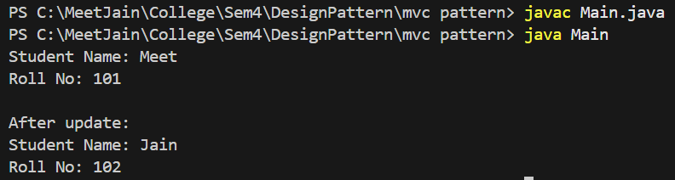

Class Diagram:
